How to get rid of double shapes:
Ex. Block A87974 – AM7EX
Issue: double Standard Unit Shapes
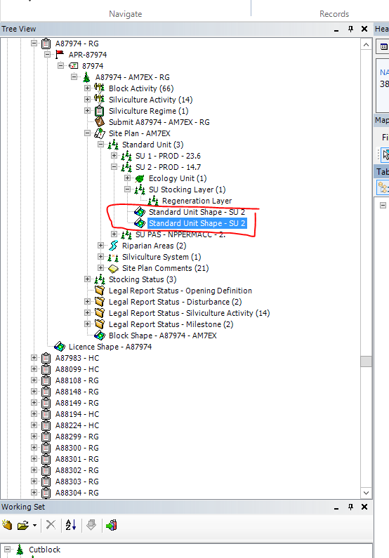
Step 1) Send to Map View
Step 2) Start an edit session
-Edit Menu top left of Map view – ‘start edit session’
Step 3) Ensure that one of the shapes is selected as the ‘edit feature’
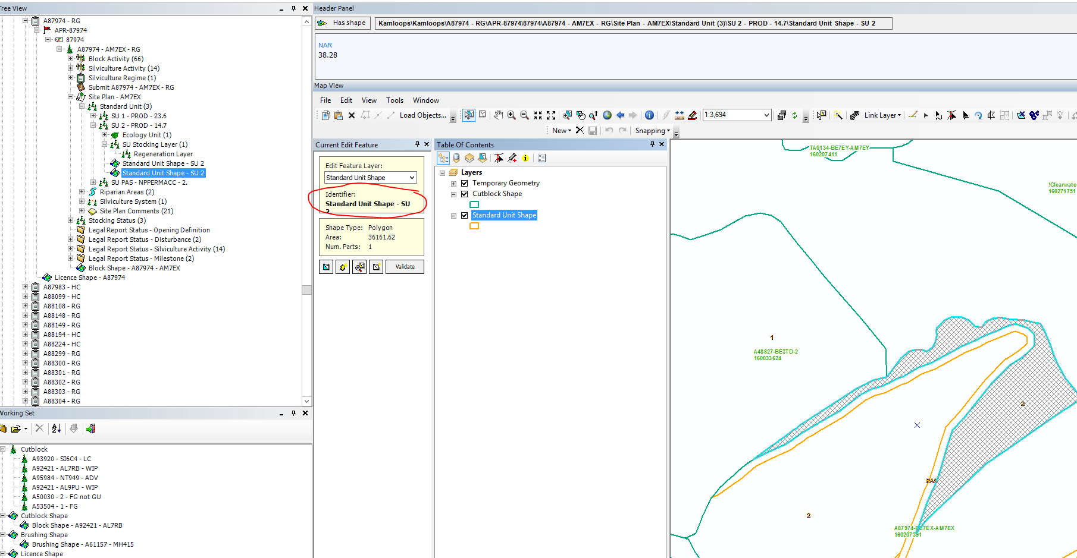
Step 4) use the Link Layer tool
-With the Link Layer tool selected hold down your shift key
-your cursor will change to have a small plus sign beside it
-while still holding the shift key, select the shape to be added to the edit feature shape.
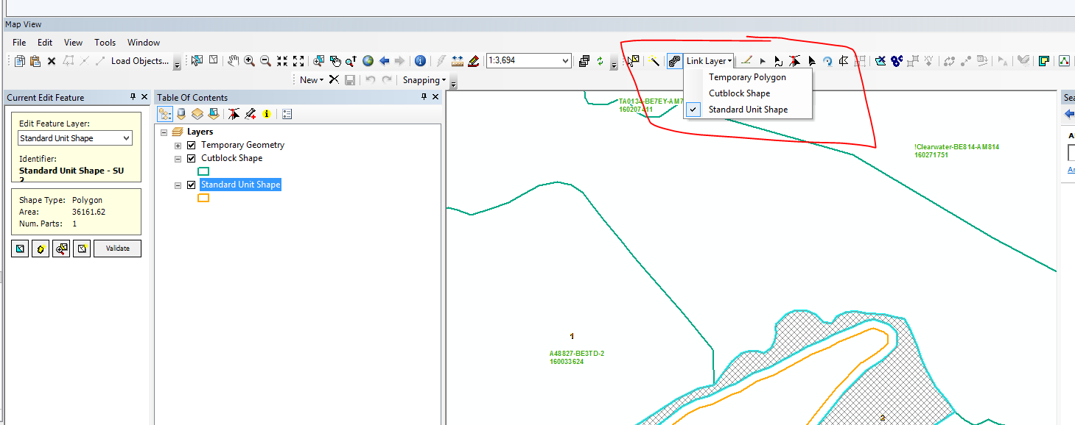

Step 5) Delete the remaining double shape
-Switch your edit feature to the shape that you now need to delete as it has been successfully linked (added) to other shape (right click the shape in the LRM tree and select ‘send to mapview’)
-once the shape is hatched (indicating it is the edit feature), use this delete key 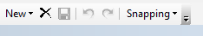 to delete the spatial along with any tabular records attached
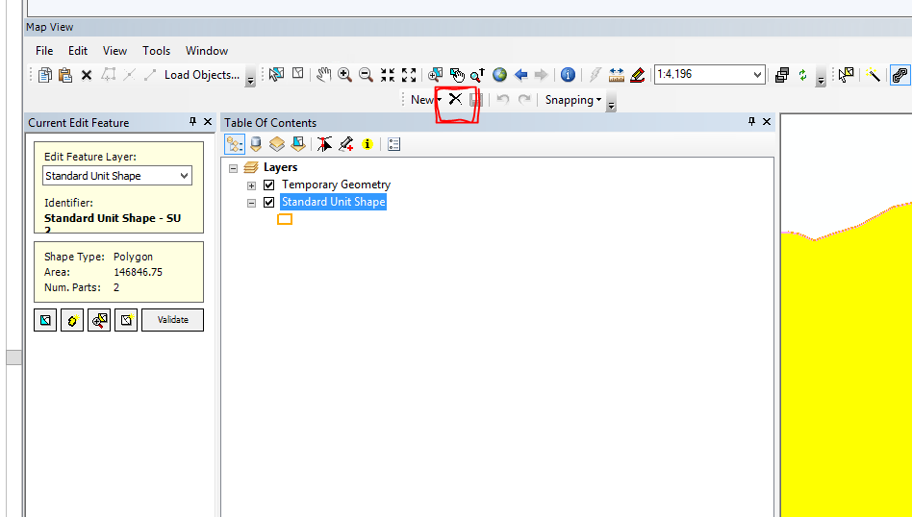

Step 6) Stop editing, save your changes, post your version
-In the LRM tree there should only be one shape that has both shapes in it
(send to map view to check)
